**A-1 . B. Scaffold**

**A-2. . B. Scaffold**

**A-3. a.**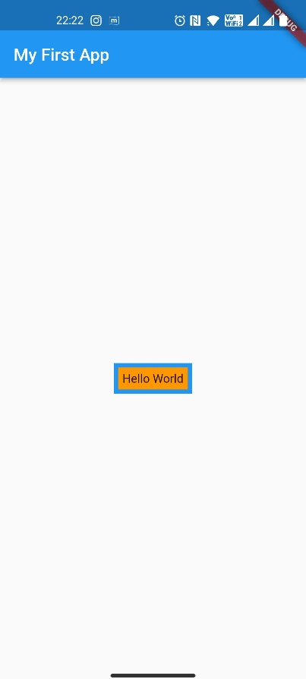

import 'package:flutter/material.dart';

void main() {

  runApp(MaterialApp(

      home: Scaffold(

    appBar: AppBar(

      title: Text("My First App"),

    ),

    body: Center(

        child: Container(

      color: Colors.blue,

      padding: EdgeInsets.all(5),

      child: Container(

        padding: EdgeInsets.all(5),

        color: Colors.orange,

        child: Text("Hello World"),

      ),

    )),

  )));

}

**A-3. b.**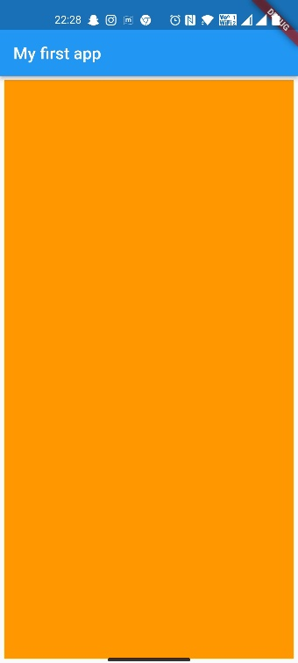

import 'package:flutter/material.dart';

void main() {

  runApp(MaterialApp(

    home: Scaffold(

      appBar: AppBar(

        title: Text("My first app"),

      ),

      body: Container(

        margin: EdgeInsets.all(5),

        color: Colors.orange,

      ),

    ),

  ));

}